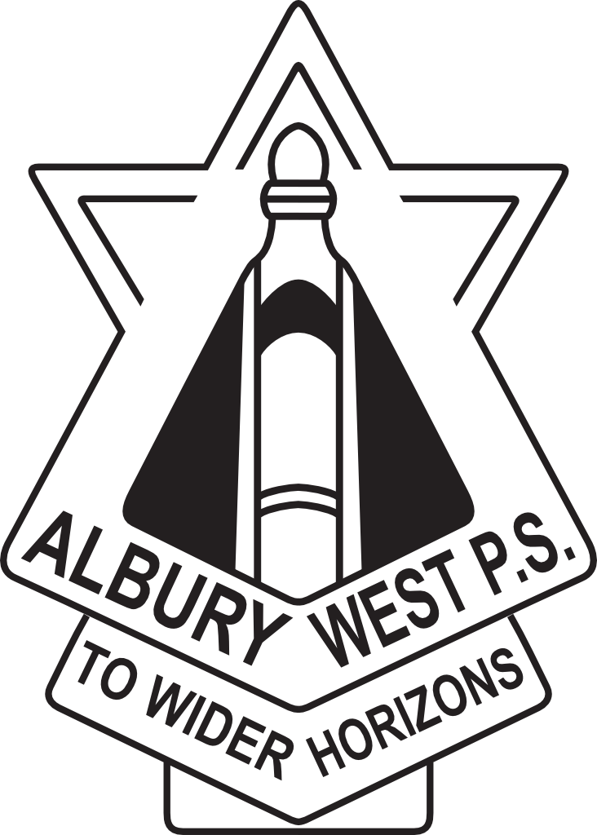
Albury West Public School P&C
UNIFORM SHOP

Open: Tuesdays 8.45 – 9.15am Thursdays 8.45 – 9.15am

New and second-hand uniforms available.

NEW STOCK PRICE LIST
Winter Jackets | Black and Gold | $65.00
V-Neck Windcheaters | Grey or Gold | $35.00
Short Sleeved Polo Shirts | Grey or Gold | $24.00
Long Sleeved Polo Shirts | Grey or Gold | $26.00
100% Cotton Unisex Shorts – DISCOUNTED – while stocks last
- With pockets | Black | $10.00
- Without pockets | Black | $8.00

Double knee tracksuit pants
- With zip pocket Black $25.00 Double knee tracksuit pants – DISCOUNTED – while stocks last
- Without zip pocket | Black | $15.00
Slouch Hats | Gold | $15.00
Bags – Large with drink holder | Black | $45.00

All second hand items are reasonably priced, generally under $5.

Payments by cash or cheque only.
New summer uniforms for girls and new grey shorts and trousers for boys are available at “Albury Wool and Uniforms”.
April 2020

